Maryam

Optometrist

Hameed

PROFILE

Aiming for the position of an Optometrist with the ability to diagnose vision problems using advanced technology and treatment plans tailored to individual needs.

## Phone

+92 3024126434

**Email** maryamhameed661@gmail. com

## Address

Thokar (Lahore).

# PROFILE



**Date of Birth:***28,Mar,1998* **Gender :***Female.*

**Marital Status:** *Single*

**Nationality :***Pakistani*

# SKILLS



* Patient care. Diagnostic testing.

Quality assurance awareness. Costumer service skills.

# EXPERIENCE



## Optometrist

*THQ hospital Pattoki (kasur) / Jun2022, - Aug,2022 /jun23_Aug23*

## Optometrist

*Basheer eye care hospital / Jun,2023 - Sep,2023*

***Optometrist***

*Mughal eye hospital / Feb,2022 - Jun,2022 / LRBT Sep22_Jan23*

# EDUCATION

## BS optometry

*University of Lahore. / Aug,2019 – Jan, 2024)*

## F.sc pre medical_(1st division)

*Superior group of colleges. / Sep,2016 - Sep,2018*

## Matric_(A+ Grade)

*Muslim model school Pattoki / Mar,2014 - Apr,2015*

# CERTIFICATIONS

**

**LANGUAGES**

* English. Urdu.

## Computer course_(A+ Grade)

*Government VTI college. / 2022*

## Islamic studies course

*Quran college and training institute / 2022*

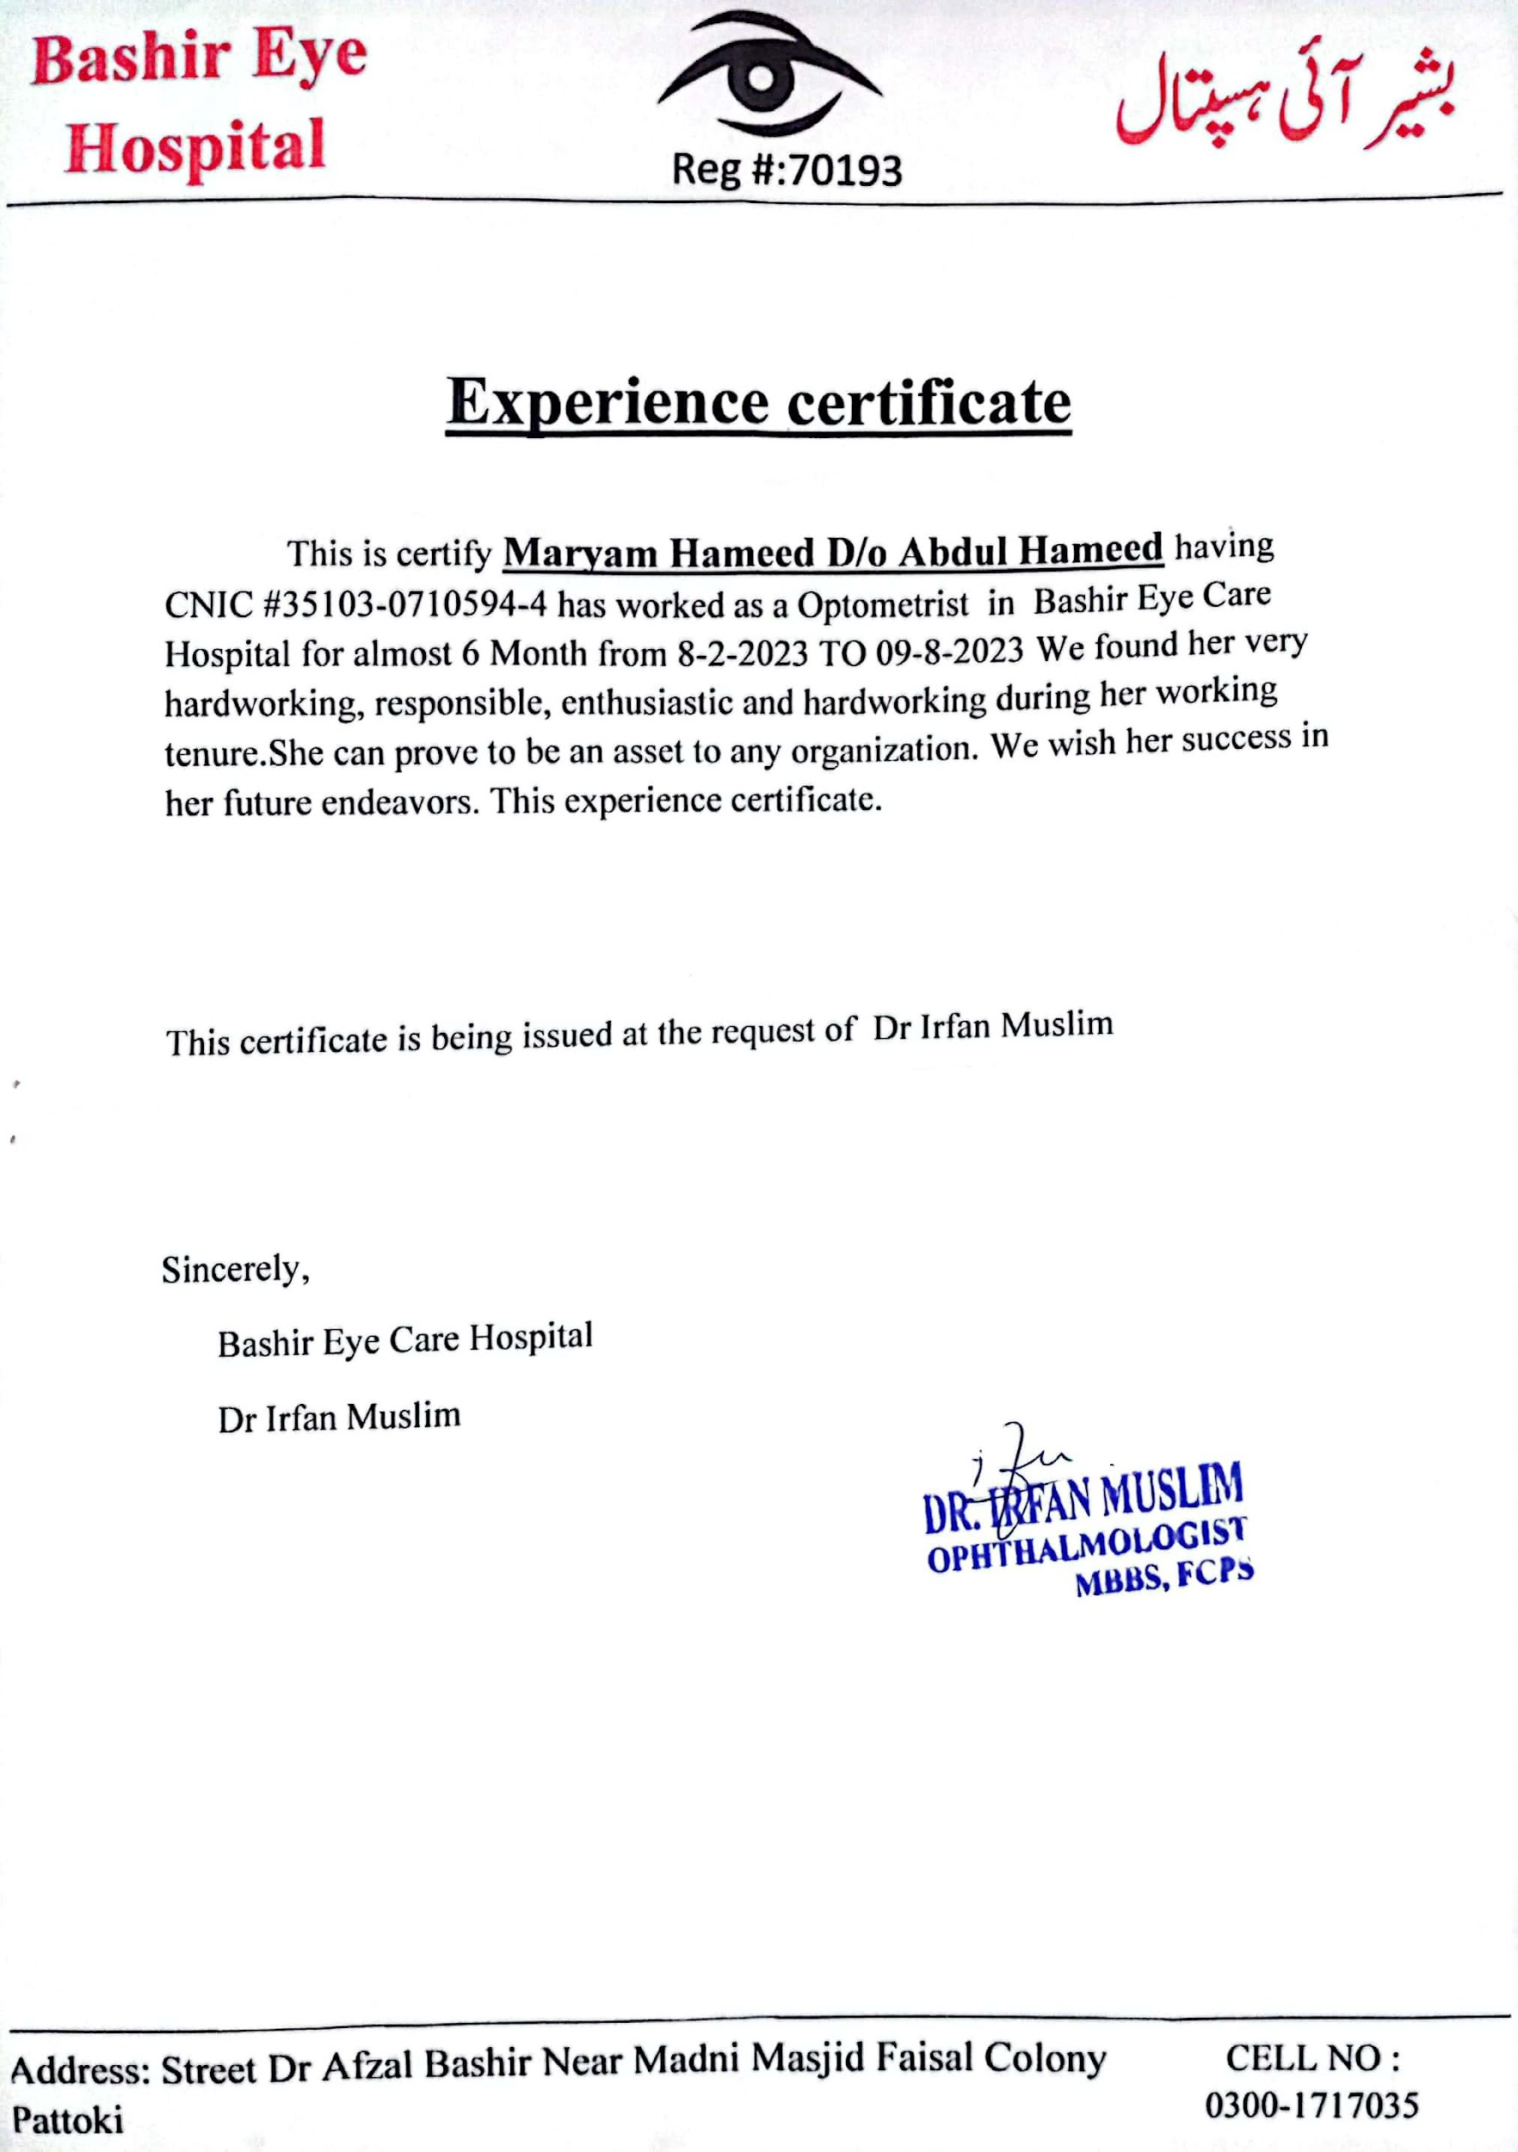

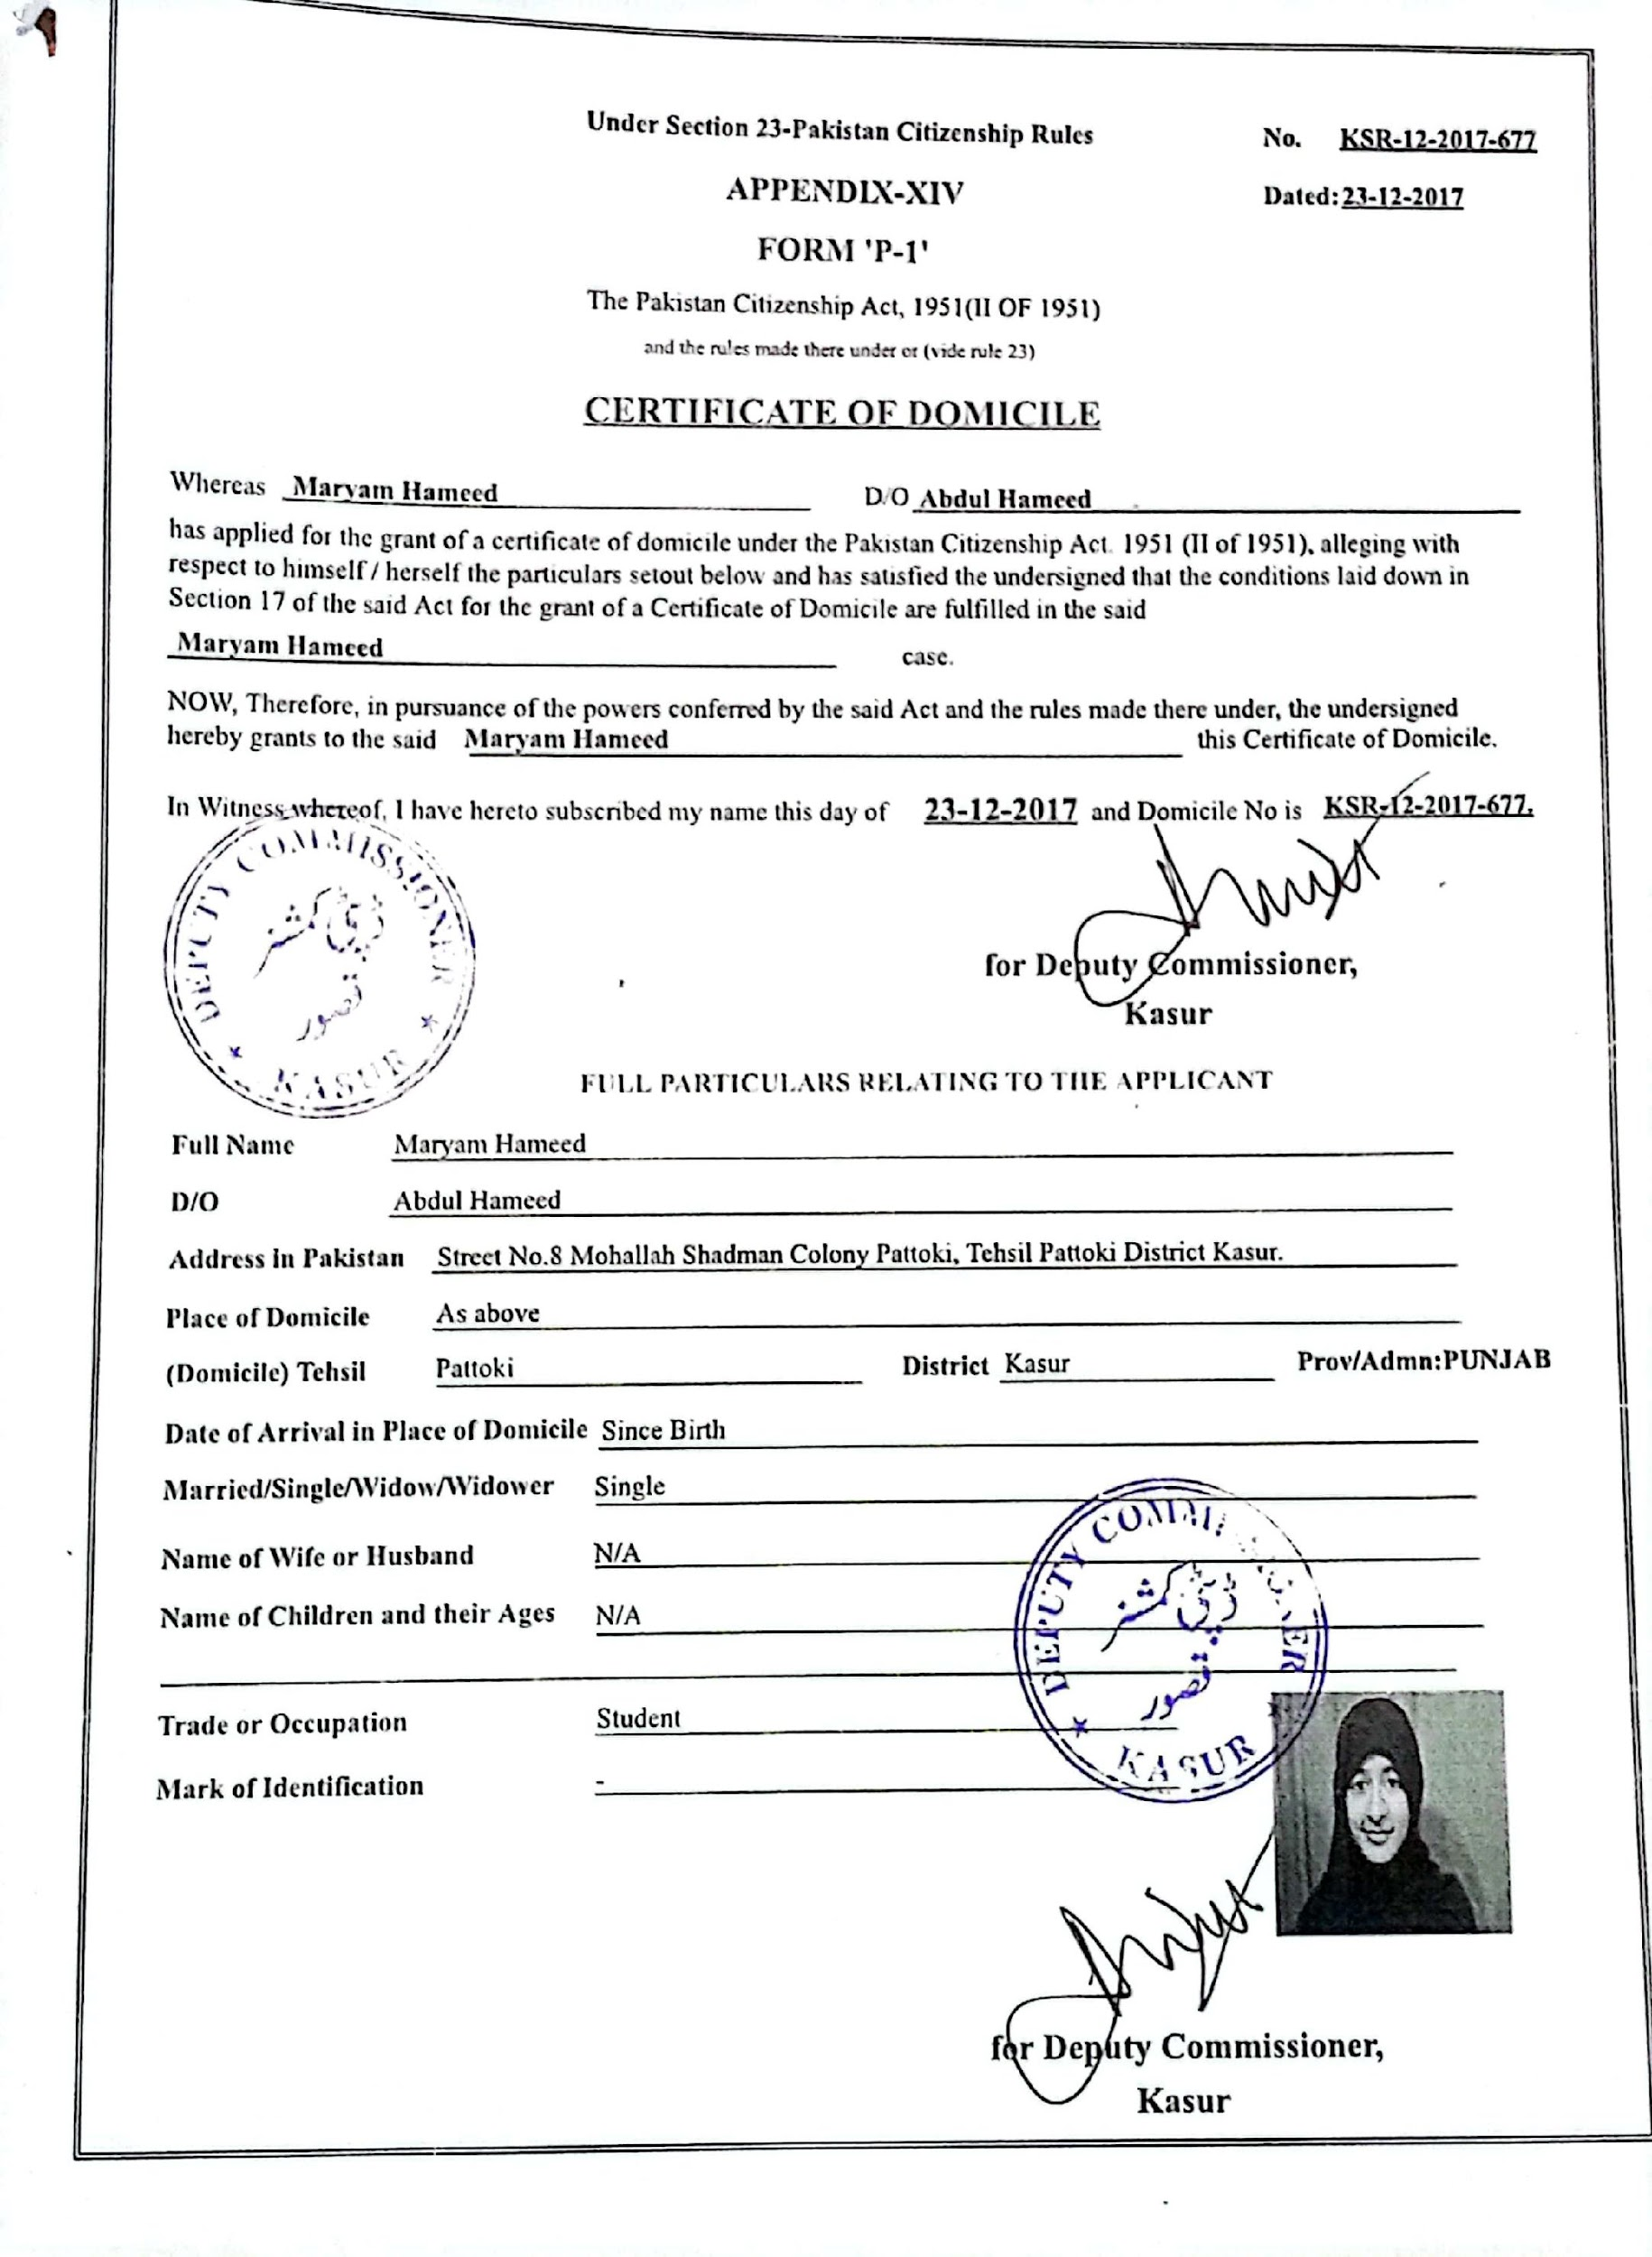

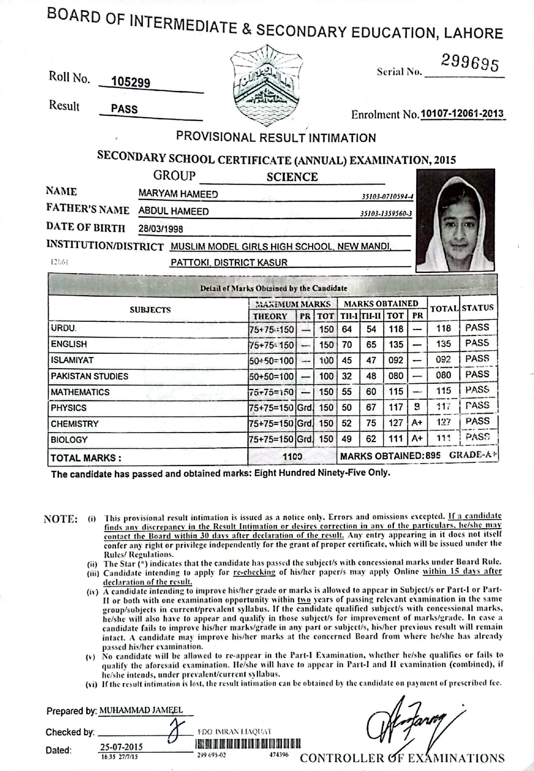

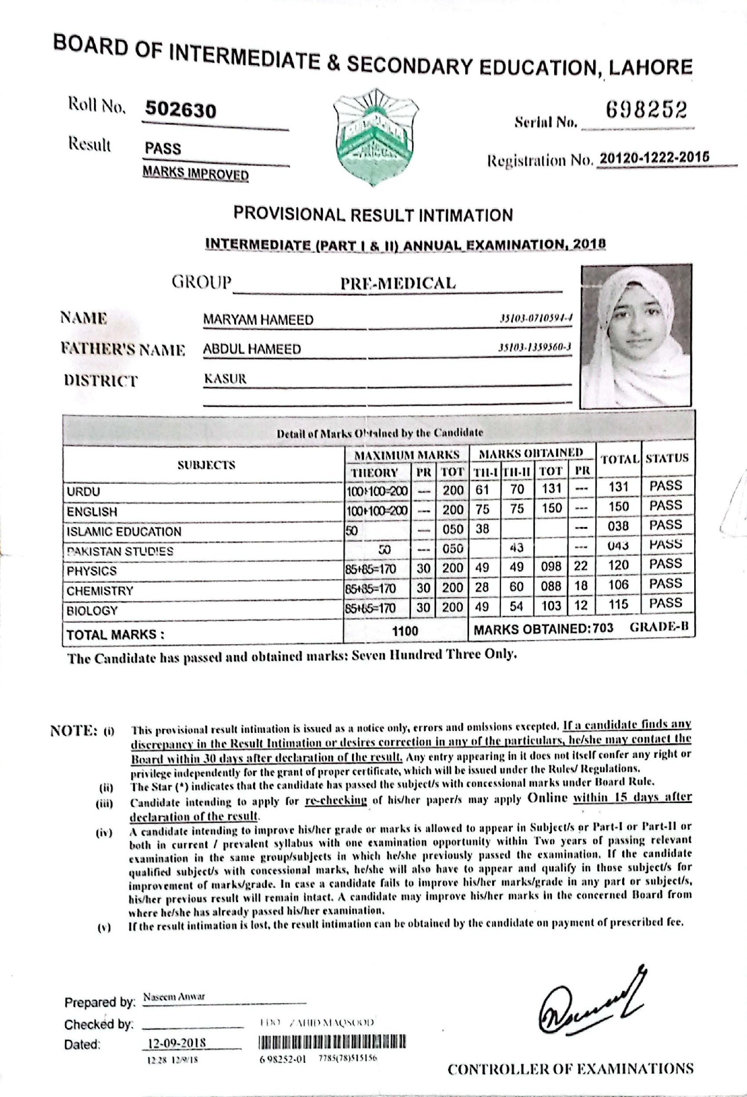

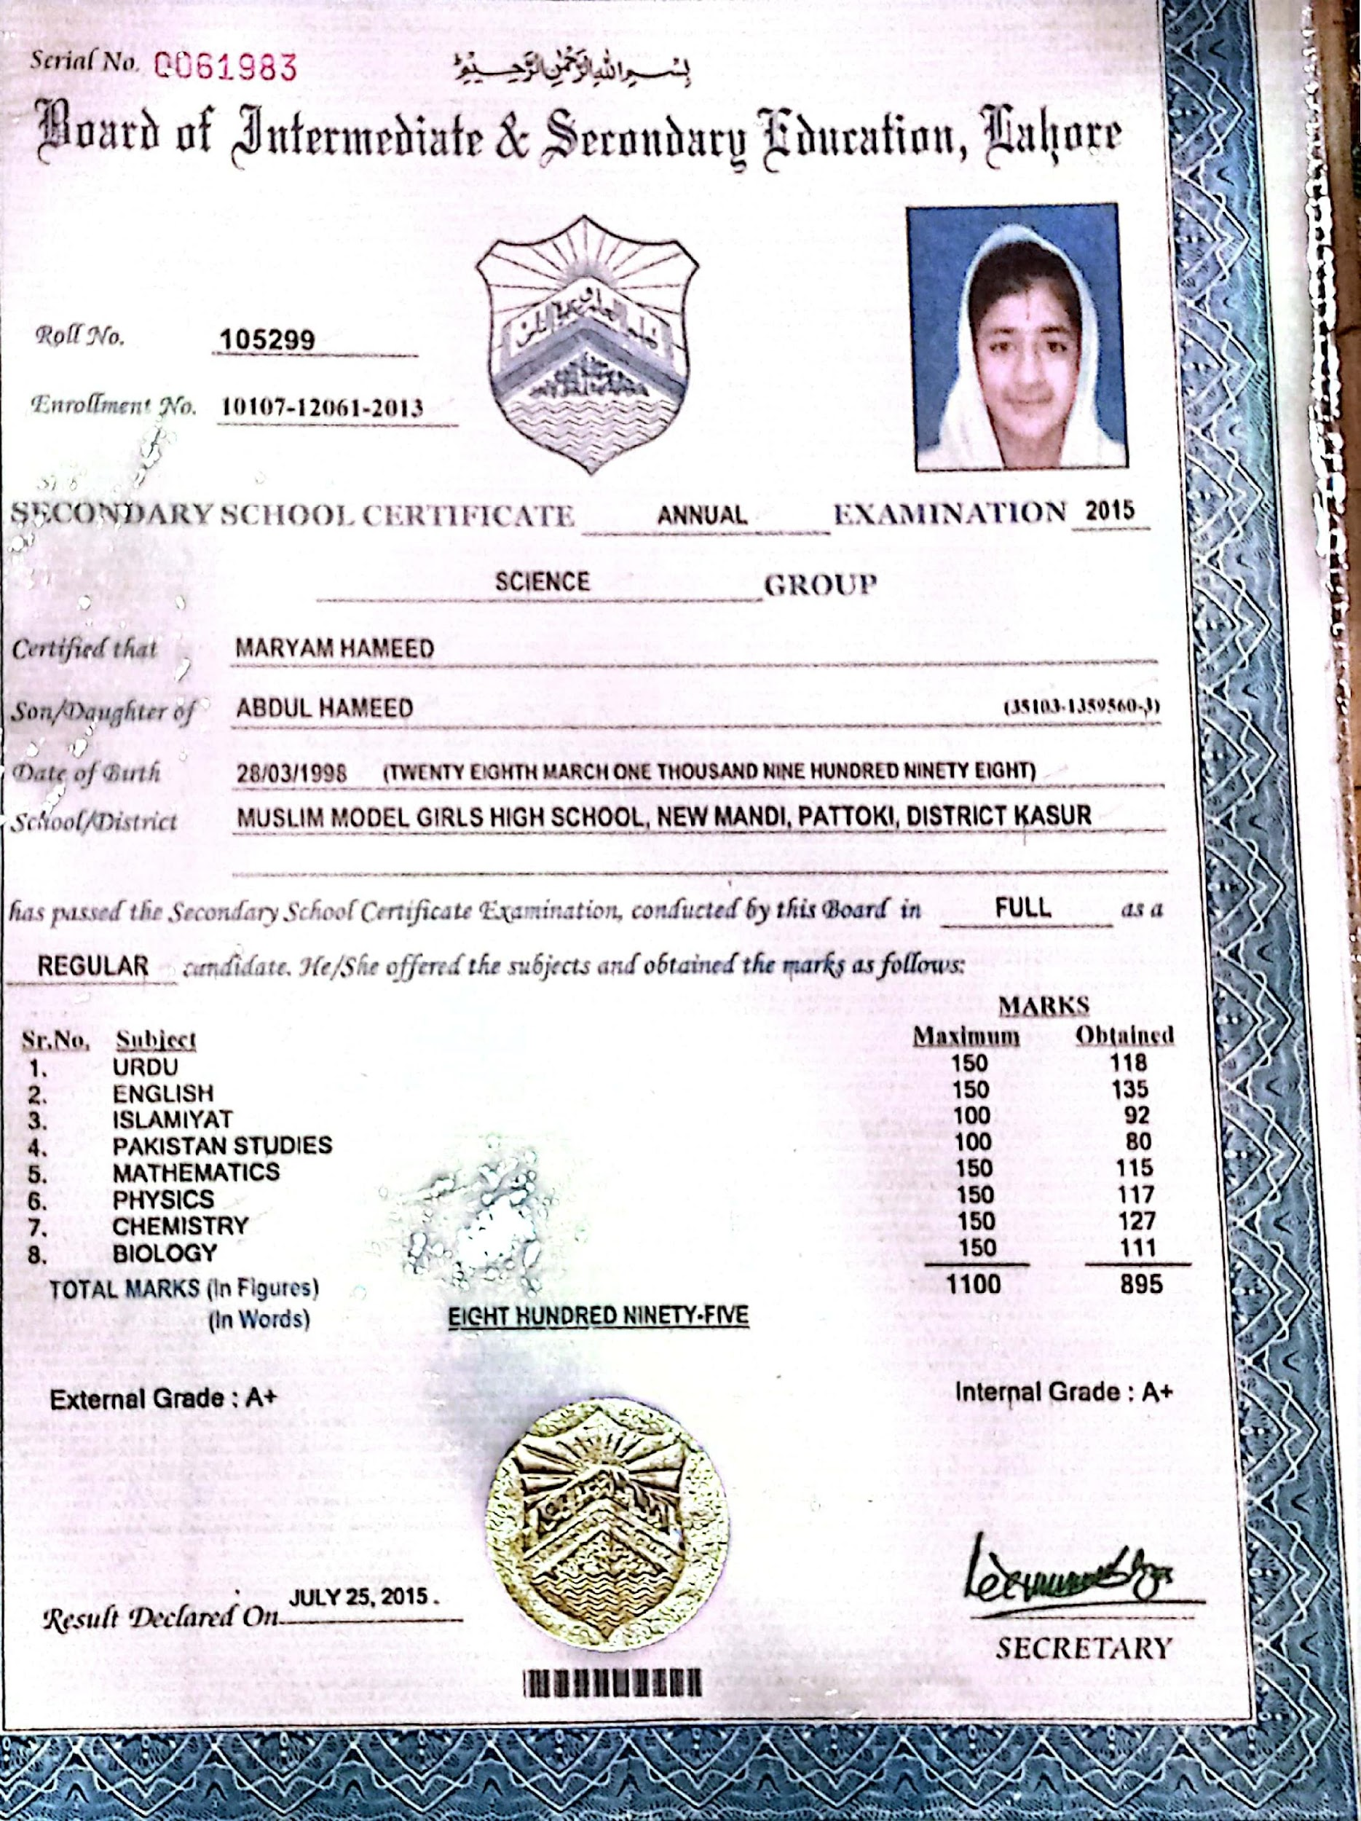

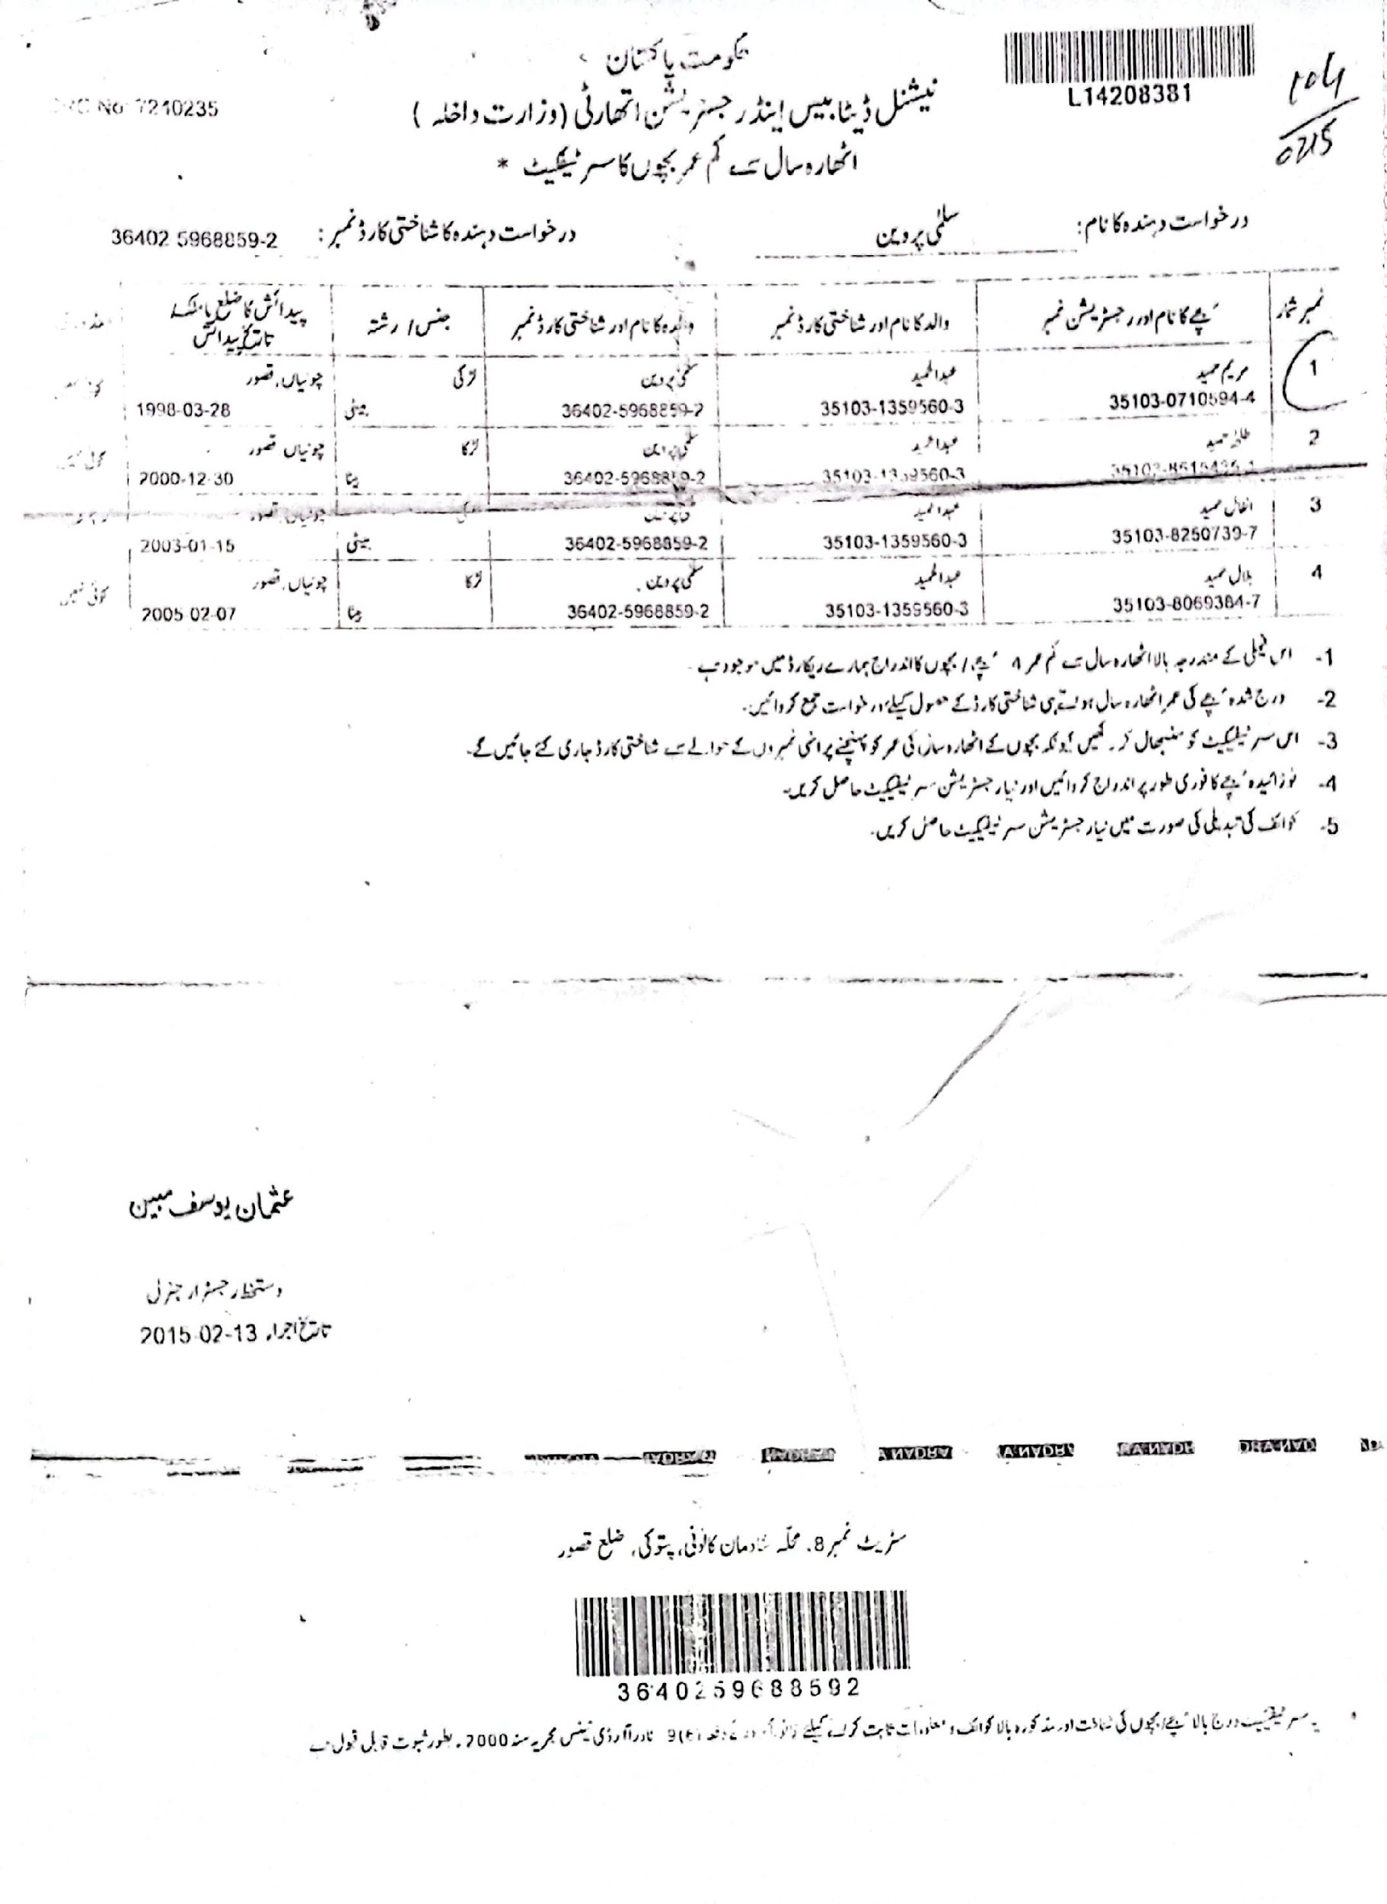

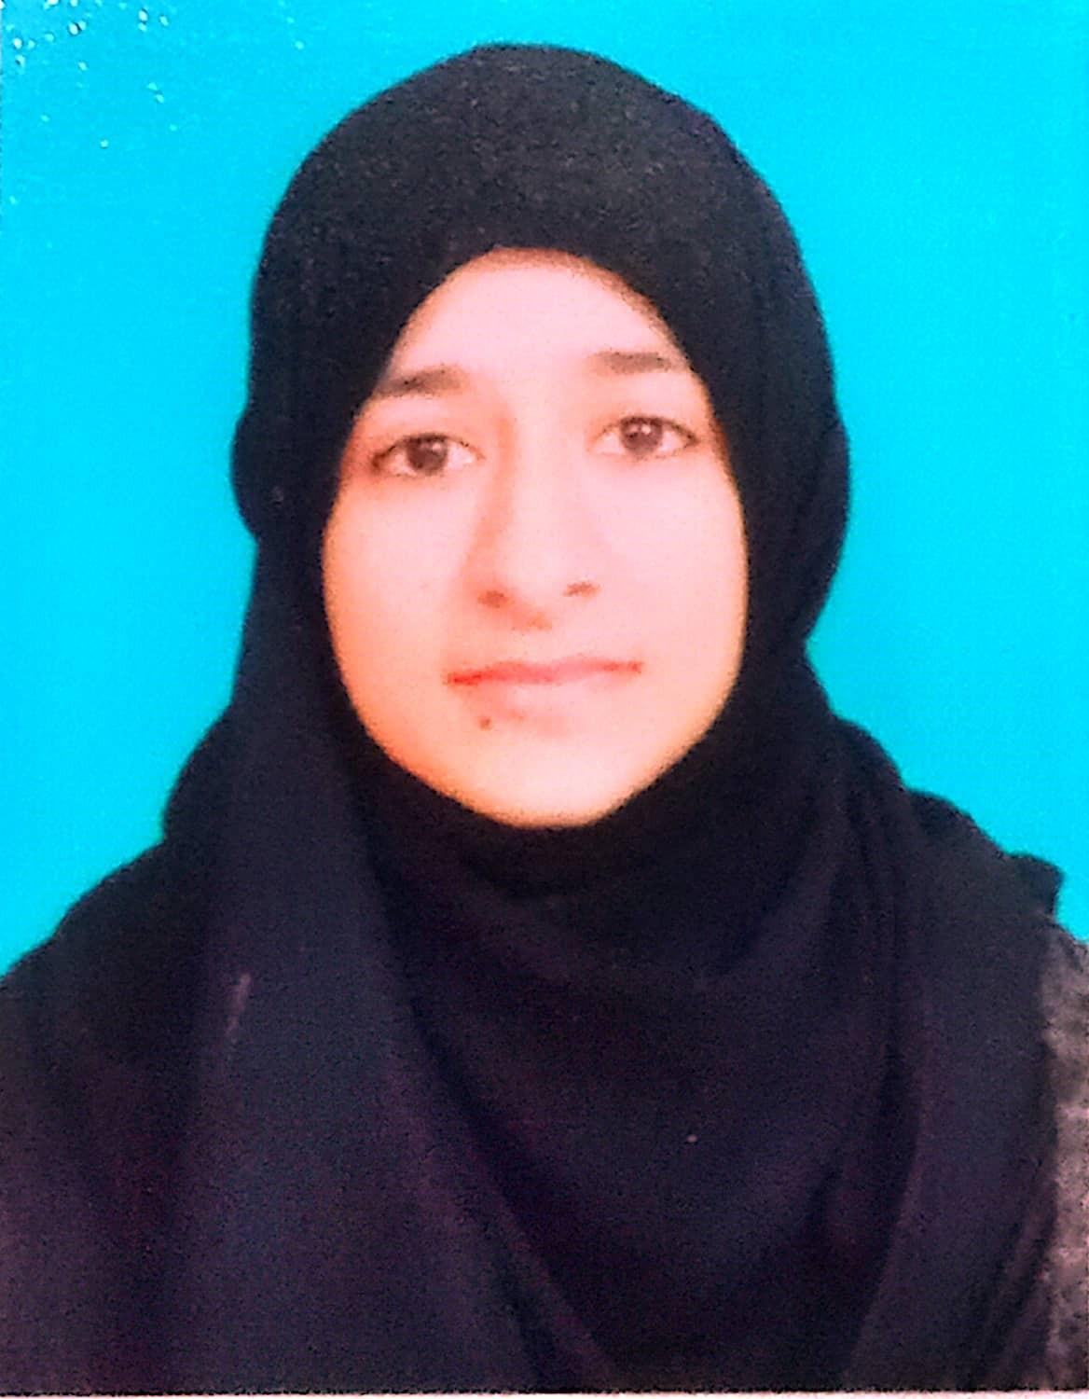

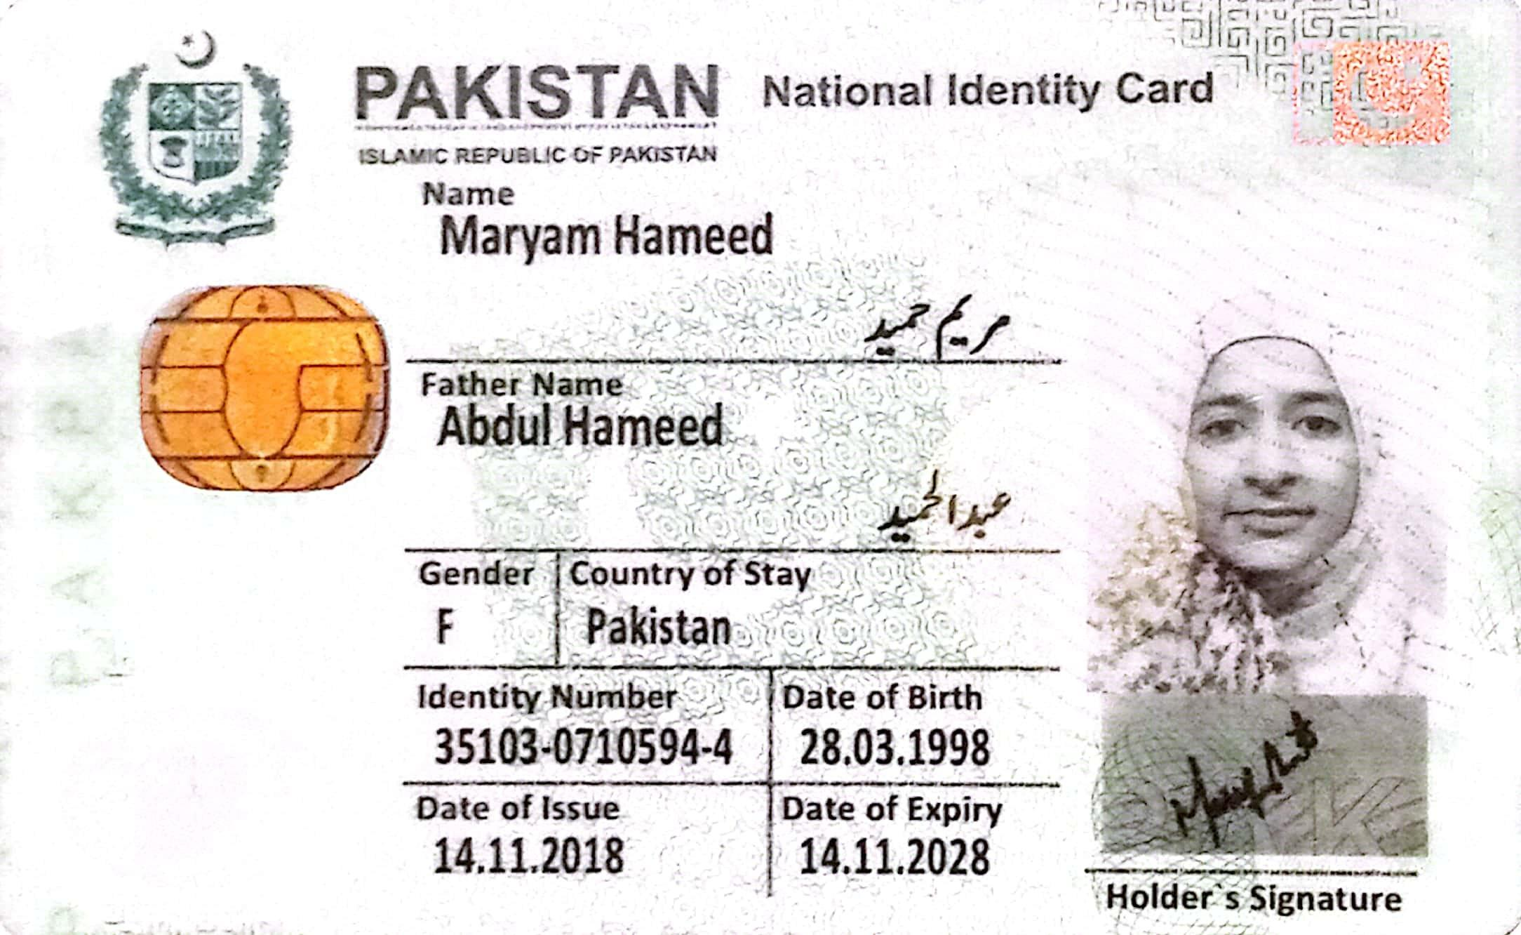

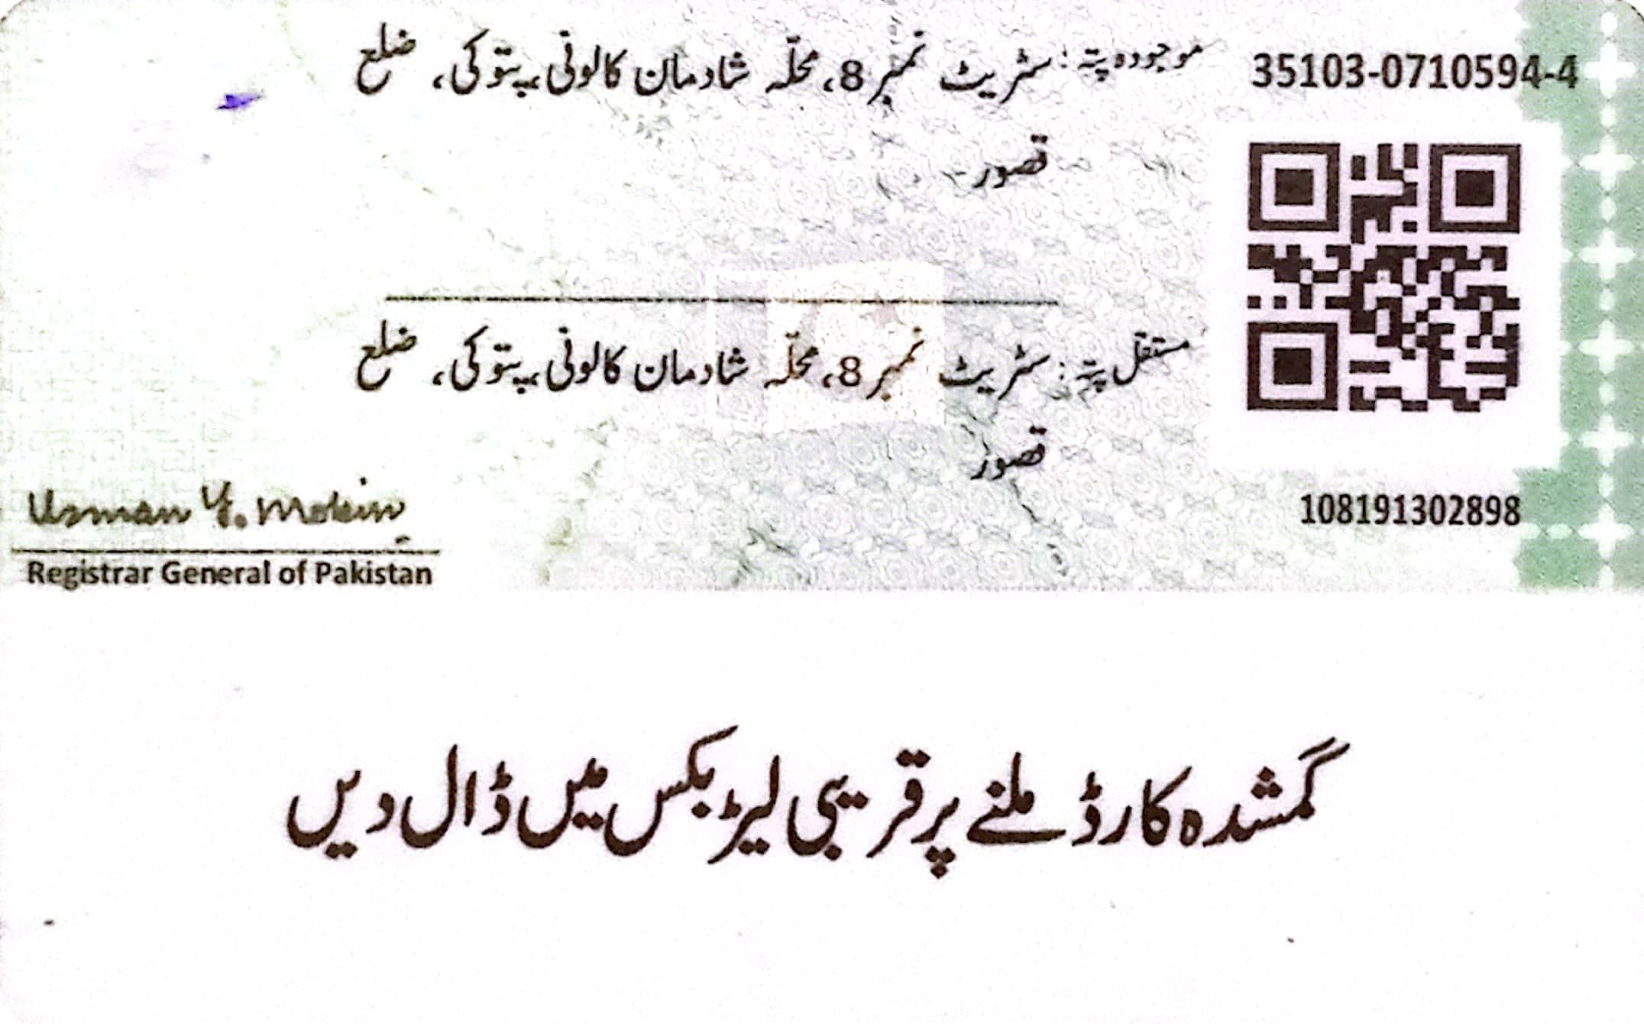

# The University Of Lahore Lahore Campus Faculty of Allied Health Sciences Department of Optometry & Vision Science

**Student Name:**MARYAM HAMEED **Father's Name:**Abdul hameed

# Batch:Spring 2019

**Student No:**70105948 **RegStatus R. Program:Bachelor of Vision Sciences**(**BVS-LHR)**

Semester 1 Spring Semester 2019

| OD-105 |  | Functional English |  |  |  | 3.0 | A |  | |
| --- | --- | --- | --- | --- | --- | --- | --- | --- | --- |
| OD-104 |  | Primary Eye Care |  |  |  | 1.0 | B |
| OD-106 |  | Pakistan Studies |  |  |  | 2.0 | A- |
| OD-102 |  | General Physiology |  |  |  | 4.0 | B |
| OD-103 |  | Biochemistry and Genetics |  |  |  | 4.0 | C |
| OD-101 |  | Human Anatomy and Histology |  |  |  | 4.0 | B+ |
| Semester | 2 | **SGPA 3.14**  Fall Semester 2019 |  | **CGPA** | **3.14** | **56.50/18** | **Earned** | **CH** | **18** |
| OD-1101 |  | Screening Observations |  |  |  | 2.0 | B |  |  |
| OD-112 |  | Islamic Studies |  |  |  | 2.0 | A- |  |  |
| OD-113 |  | English-B (Communication, Technical | Writing | and |  | 3.0 | B |  |  |
| OD-109 |  | Ocular Anatomy |  |  |  | 3.0 | A |  |  |
| OD-110 |  | Ocular Physiology |  |  |  | 3.0 | B+ |  |  |
| OD-107 |  | General Pathology |  |  |  | 3.0 | D+ |  |  |
| OD-1008 |  | General and Ocular Pharmacology |  |  |  | 2.0 | B+ |  |  |
| Semester | 3 | **SGPA 3.14**  Spring Semester 2020 |  | **CGPA** | **3.14** | **113.00/36** | **Earned** | **CH** | **18** |
| OD-115 |  | Clinical Medicine |  |  |  | 3.0 | A |  |  |
| OD-116 |  | Geometrical and Physical Optics |  |  |  | 3.0 | A |  |  |
| OD-117 |  | Vision Sciences |  |  |  | 3.0 | B+ |  |  |
| OD-118 |  | Ocular Disease Basics-I |  |  |  | 3.0 | A |  |  |
| OD-119 |  | Communication Skills |  |  |  | 3.0 | A |  |  |
| OD-120 |  | Introduction to Computers |  |  |  | 3.0 | A |  |  |
| OD-114 |  | Community Medicine |  |  |  | 2.0 | A |  |  |
| Semester | 4 | **SGPA 3.92**  Fall Semester 2020 |  | **CGPA** | **3.42** | **191.50/56** | **Earned** | **CH** | **20** |
| OD-125 |  | Refraction |  |  |  | 3.0 | A- |  |  |
| OD-123 |  | Ocular Disease Basic-II |  |  |  | 3.0 | B+ |  |  |
| OD-121 |  | Optometric Procedures-I |  |  |  | 3.0 | B+ |  |  |
| OD-126 |  | Mathematics for Optometry |  |  |  | 2.0 | A |  |  |
| OD-122 |  | Ophthalmic Nursing |  |  |  | 1.0 | A |  |  |
| OD-127 |  | Behavioral Sciences |  |  |  | 2.0 | A |  |  |
| OD-124 |  | Physiological and Visual Optics |  |  |  | 3.0 | A- |  |  |
|  |  | **SGPA 3.73** |  | **CGPA** | **3.49** | **255.00/73** | **Earned** | **CH** | **17** |
| Semester | 5 | Spring Semester 2021 | |  |  |  |  |  |  |
| OD-132 |  | Advance Ocular Diseases I | |  |  | 3.0 | A |  |  |
| OD-131 |  | Optometric Procedures II (instrumentation) | |  |  | 3.0 | A- |  |  |
| OD-133 |  | Advance Refraction and Visual Functions | |  |  | 3.0 | B+ |  |  |
| OD-134 |  | Medical Ethics | |  |  | 1.0 | A- |  |  |
| OD-128 |  | Fundamentals of Surgery | |  |  | 2.0 | A |  |  |
| OD-130 |  | Strabisums | |  |  | 2.0 | B |  |  |
| OD-129 |  | Ophthalmic Dispensing I | |  |  | 3.0 | C+ |  |  |
| OD-135 |  | Clinical Practice | |  |  | 1.0 | A- |  |  |
|  |  | **SGPA 3.49** | | **CGPA** | **3.49** | **317.75/91** | **Earned** | **CH** | **18** |

| Semester | 6 | Fall Semester 2021 | |  | | | | | |
| --- | --- | --- | --- | --- | --- | --- | --- | --- | --- |
| OD-140 |  | Pediatric Optometry | |  |  | 3.0 | B |  |  |
| OD-141 |  | Clinical Practice | |  |  | 3.0 | A- |  |  |
| OD-137 |  | Contact Lens I | |  |  | 2.0 | D+ |  |  |
| OD-138 |  | Low Vision I | |  |  | 2.0 | A- |  |  |
| OD-136 |  | Ophthalmic Dispensing II | |  |  | 3.0 | B |  |  |
| OD-139 |  | BSV and Orthoptic Techniques (Amblyopia) | |  |  | 3.0 | C+ |  |  |
| OD-142 |  | Applied Statistics for Optometrists | |  |  | 2.0 | A |  |  |
| Semester | 7 | **SGPA 3.07**  Spring Semester 2022 | | **CGPA** | **3.42** | **373.00/109** | **Earned** | **CH** | **18** |
| OD-147 |  | Public Health Optometry | |  |  | 2.0 | C+ |  |  |
| OD-146 |  | Clinical Refraction and Instrumentation | |  |  | 2.0 | B+ |  |  |
| OD-143 |  | Low Vision Rehabilitation and Geriatrics | |  |  | 3.0 | B |  |  |
| OD-148 |  | Clinical Practice | |  |  | 4.0 | B |  |  |
| OD-149 |  | Advance Ocular Diseases II | |  |  | 3.0 | B+ |  |  |
| OD-145 |  | Contact Lens II | |  |  | 3.0 | C+ |  |  |
| OD-144 |  | Neuro-Ophthalmology | |  |  | 3.0 | C |  |  |
| **SGPA 2.85** | | | | **CGPA** | **3.33** | **430.00/129 Earned** | | **CH** | **20** |
| Semester | 8 | Fall Semester 2022 | | |  |  |  |  |  |
| OD-154 |  | Ocular Pharmacology | | |  | 2.0 | B+ |  |  |
| OD-153 |  | Clinical Practice | | |  | 4.0 | B |  |  |
| OD-150 |  | Clinical Reasoning and Diagnostic Procedures | | |  | 2.0 | B |  |  |
| OD-152 |  | Basic and Advance Ocular Diseases | | |  | 2.0 | B+ |  |  |
| OD-151 |  | Clinical Problem Solving | | |  | 2.0 | B+ |  |  |
| Semester | 9 | **SGPA 3.25 CGPA**  Spring Semester 2023 | | | **3.33** | **469.00/141** | **Earned** | **CH** | **12** |
| OD-157 |  | Clinical Rotations III (Diagnostic, Peads and | | |  | 6.0 | B |  |  |
| OD-155 |  | Clinical Rotations I (Refraction, Screening and | | |  | 6.0 | B+ |  |  |
| OD-156 Clinical Rotations II (Contact Lens, Dispensing, Low 6.0 D | | | | | | | | | |
| Semester | 10 | **SGPA 2.50**  Fall Semester 2023 |  | **CGPA** | **3.23** | **514.00/159 Earned** | | **CH** | **18** |
| OD-158 |  | Clinical Rotations IV | (Vireo-Retina Clinic and |  |  | 7.0 B+ | |  |  |
|  |  | **SGPA 3.50** |  | **CGPA** | **3.24** | **538.50/166 Earned** | | **CH** | **7.0** |

Note:

Standing = Status = Pass

TOTAL CREDIT HOURS ATTEMPTED = **166**

TOTAL CREDIT HOURS EARNED = **166**

CUMULATIVE GRADE POINT AVERAGE(CGPA) = **3.24**

1. This report is for your information and has been displayed for updating your record. In case of any discrepencies please indicate.
2. In no case the display is final version